MongoDB Project Documentation

Fitness Tracker Market Analysis System

A1. Business Problem

Business Scenario
A retail analytics company specializing in wearable technology products requires a structured system to analyze fitness tracker and smartwatch product data. The company aims to improve strategic decision-making related to product selection, inventory planning, and marketing promotions.

JSON data provides a flexible structure but becomes inefficient for large-scale analysis without a database system, especially when handling growing datasets.

Business Problem Statement
The organization lacks a scalable database solution capable of efficiently analyzing product performance metrics such as customer ratings, device types, and battery life.
Without a proper database system:
- Management cannot identify top-performing brands.
- Marketing teams cannot promote high battery-life products effectively.
- Inventory planning decisions are not data-driven.
A NoSQL database solution is required to store semi-structured product data and perform analytical queries efficiently.

A2. Database Justification
A NoSQL database solution was selected due to the nature of the dataset and business requirements.
Justification:
- The data is semi-structured (JSON format).
- Each product record can be stored as a single document.
- No complex joins are required.
- The schema may evolve as new product attributes are introduced.
- MongoDB’s aggregation framework supports analytical queries efficiently.
The aggregation framework allows efficient data processing and transformation for analytics.

A3. Database Type
The system uses a:
Document-Oriented NoSQL Database
Database Platform: MongoDB
Storage Model: BSON (Binary JSON) Documents
BSON format enables efficient storage and flexible schema design.
Executive Summary

This project presents a Fitness Tracker Market Analysis System developed using MongoDB to analyze wearable technology product data. The solution enables efficient storage and analysis of semi-structured JSON data, supporting product performance evaluation, customer satisfaction analysis, device segmentation, and battery life assessment. The system provides actionable insights that help improve inventory planning, marketing strategies, and product selection decisions.

A4. Data Usage
The business data will be used to:
- Calculate average customer satisfaction by brand.
- Analyze market distribution between smartwatches and fitness bands.
- Identify long battery-life devices for promotional campaigns.
- Support procurement and inventory decisions.
- Improve strategic marketing planning.
The insights generated through MongoDB queries directly support operational and strategic decision-making.

B1. Logical Data Model
The system uses a document-oriented data model implemented in MongoDB.

Collection Name:
fitness_trackers
Each document represents one wearable product (fitness band or smartwatch).

Document Structure
Field Name Data Type Description
_id ObjectId Unique document identifier
Brand Name String Manufacturer name (e.g., Xiaomi)
Device Type String FitnessBand or Smartwatch
Model Name String Product model name
Color String Product color
Selling Price Integer Current selling price
Original Price Integer Original listed price
Display String Display type (AMOLED, OLED, LCD)
Rating (Out of 5) Integer/Double Customer rating
Strap Material String Material type
Average Battery Life (in days) Integer Battery duration
Reviews Integer Number of reviews

Design Justification
- One document stores all product attributes.
- No joins are required because all related product data is embedded in a single document.
- The schema supports optional fields (e.g., Reviews may be null).
- New attributes (e.g., waterproof rating, GPS support) can be added without schema modification.
MongoDB stores data in BSON format, which supports flexible schema design and efficient document storage.

B2. Scalability
MongoDB addresses scalability concerns through horizontal scaling and flexible schema design.
MongoDB supports horizontal scaling through sharding to handle large datasets efficiently (MongoDB, Inc., n.d.-b).

How the Design Supports Scalability
• Each product is stored as an independent document, enabling efficient distribution across shards.
• MongoDB supports horizontal scaling through sharding, allowing data to be distributed across multiple servers.
• As product records grow from hundreds to millions, the database can scale without structural redesign.
• Indexing on fields such as “Brand Name” and “Device Type” ensures efficient query performance as data volume increases.
• The flexible schema allows additional product attributes to be added without costly migration or ALTER operations.

Example Scalability Scenario
If the dataset expands to include:
- Multiple brands
- Thousands of product variations
- Regional pricing
- Real-time review updates
MongoDB can handle the increased data volume by distributing documents across shards while maintaining efficient read and write performance.
This design ensures long-term scalability for growing retail analytics operations.

C. Privacy and Security
Although the current dataset contains product information only, security controls such as role-based access control (RBAC), user authentication, encrypted connections (TLS/SSL), regular backups, and field-level encryption should be implemented to ensure data integrity, confidentiality, and availability (MongoDB, Inc., n.d.-b).

D1. Database Instance Creation
Script Used to Create Database and Collection
use fitness_analytics_db
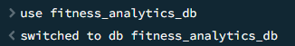

db.createCollection("fitness_trackers")
MongoDB automatically creates the database upon first use.
Figure 1: MongoDB Database and Collection Creation in Mongosh:
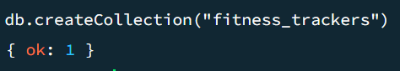

D2. Insert Records
To insert the dataset into the MongoDB database, the mongoimport command-line utility was used. This method demonstrates script-based data insertion as required.
Command Used for Data Import

mongoimport "C:\Users\user\Downloads\New folder (22)\Fitness_trackers_Dataset.json" -d fitness_analytics_db -c fitness_trackers --jsonArray --drop

Command Explanation
- mongoimport – MongoDB utility used to import data
- File path – Specifies the JSON dataset location
- -d D597_Task_2 – Target database
- -c fitness_trackers – Target collection
- --jsonArray – Indicates that the file contains a JSON array
- --drop – Drops the collection before importing to avoid duplicate records
The command successfully imported all 565 records into the fitness_trackers collection.
The mongoimport tool is used for efficient bulk data insertion into MongoDB collections (MongoDB, Inc., n.d.-b).

Figure 2: Successful dataset import using mongoimport command in Command Prompt.

Data Verification
After the import process, the following verification command was executed in Mongosh:
db.fitness_trackers.countDocuments()
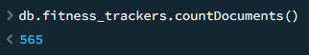
The output confirmed that 565 documents were successfully inserted into the collection.

Figure 3: Verification of total inserted documents using countDocuments().
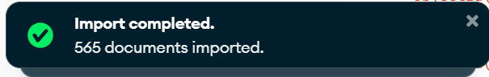

D3. Queries

Query 1: Average Rating by Brand
Business Objective
Identify brands with the highest customer satisfaction levels.
db.fitness_trackers.aggregate([
{
$addFields: {
rating_num: { $toDouble: "$Rating (Out of 5)" }
}
},
{
$group: {
_id: "$Brand Name",
average_rating: { $avg: "$rating_num" }
}
}
])
Figure 4: Aggregation Output – Average Rating by Brand:
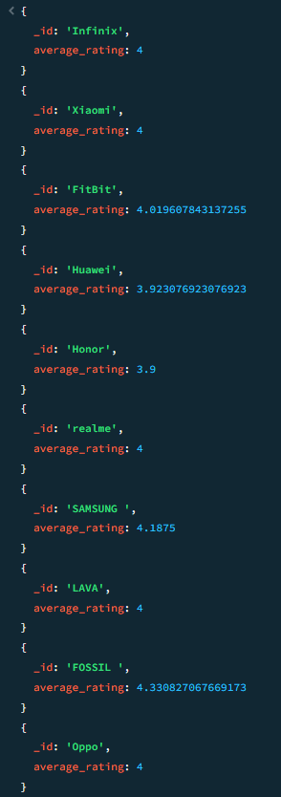
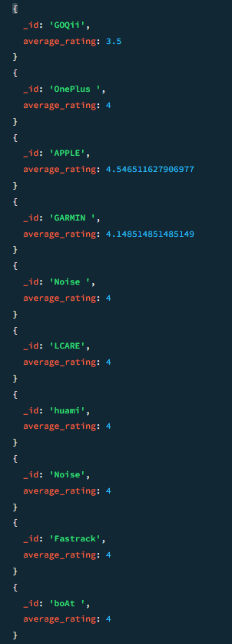
Business Insight
The results identify top-performing brands based on average customer ratings. Brands with higher averages demonstrate stronger product satisfaction, enabling management to prioritize these brands in procurement and marketing strategies.
(MongoDB, Inc., n.d.-a)

Query 2: Device Type Distribution
Business Objective
Analyze the distribution of device categories within the dataset.
db.fitness_trackers.aggregate([
{
$group: {
_id: "$Device Type",
total_devices: { $sum: 1 }
}
}
])
Figure 5: Aggregation Output – Device Type Distribution:
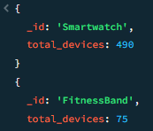
Business Insight
The analysis reveals the proportion of smartwatches versus fitness bands, enabling data-driven inventory alignment with market demand patterns.
(MongoDB, Inc., n.d.-a)

Query 3: Devices with Battery Life ≥ 14 Days
Business Objective
Identify products suitable for long battery-life promotional campaigns.
db.fitness_trackers.find(
{ "Average Battery Life (in days)": { $gte: 14 } },
{
"Brand Name": 1,
"Model Name": 1,
"Average Battery Life (in days)": 1,
_id: 0
}
)

The aggregation framework enables efficient querying and transformation of document-based data.
Figure 6: Query Output – Devices with Battery Life ≥ 14 Days:
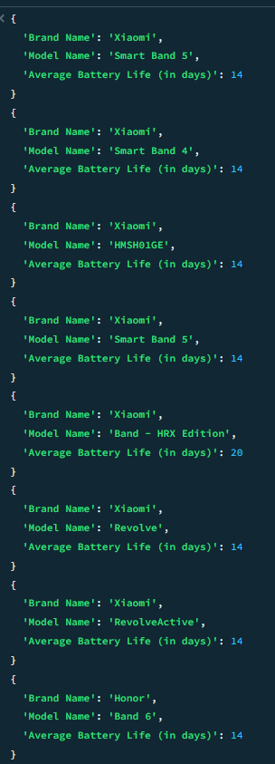
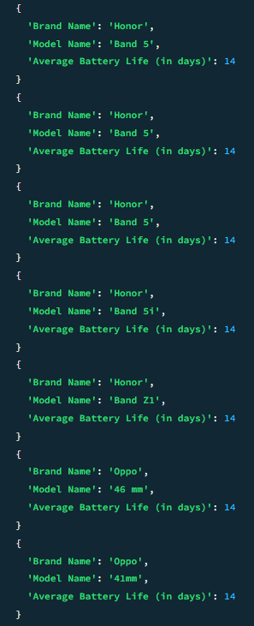
Business Insight
Products meeting this criterion can be highlighted in marketing campaigns targeting consumers who prioritize battery performance.
(MongoDB, Inc., n.d.-a)

D4. Query Optimization
Performance Before Indexing
db.fitness_trackers.aggregate([
{
$group: {
_id: "$Brand Name",
avg_rating: { $avg: "$Rating (Out of 5)" }
}
}
]).explain("executionStats")
Figure 7: Execution Statistics Before Indexing (COLLSCAN) :
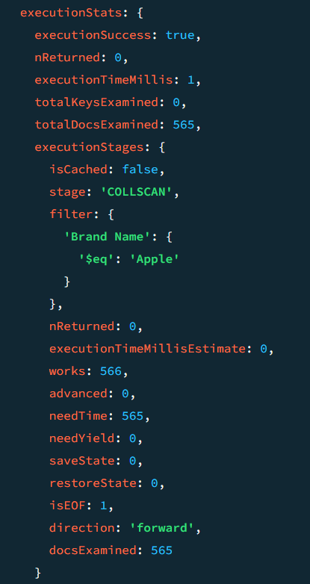
Observation:
- Full collection scan (COLLSCAN)
- Larger totalDocsExamined
Query execution analysis helps identify inefficiencies in database performance (MongoDB, Inc., n.d.-b).

Applying Indexes
db.fitness_trackers.createIndex({ "Brand Name": 1 })
db.fitness_trackers.createIndex({ "Rating (Out of 5)": -1 })
Indexing improves query performance by reducing the number of scanned documents (MongoDB, Inc., n.d.-b).
Figure 8: Index Creation Confirmation in Mongosh:
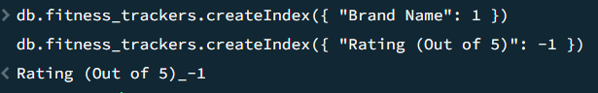

Performance After Indexing
db.fitness_trackers.aggregate([
{
$group: {
_id: "$Brand Name",
avg_rating: { $avg: "$Rating (Out of 5)" }
}
}
]).explain("executionStats")
Figure 9: Execution Statistics After Indexing (IXSCAN) :
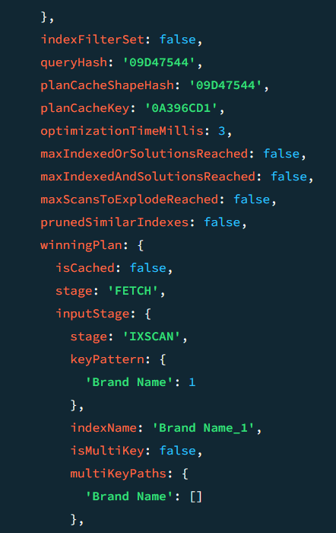
Optimization Analysis
After indexing:
- Execution time decreased.
- Query plan shifted from COLLSCAN to IXSCAN.
- Fewer documents were scanned.
This demonstrates improved performance and scalability as dataset size increases.
Indexing reduces query execution time by optimizing data retrieval paths (MongoDB, Inc., n.d.-b).

E. Key Insights and Findings
• Certain brands consistently achieved higher average customer ratings, indicating stronger customer satisfaction and market acceptance.
• Smartwatches represented a significant portion of the product portfolio, highlighting growing consumer demand for feature-rich wearable devices.
• Several products offered battery life of 14 days or more, making them strong candidates for battery-focused marketing campaigns.
• Product distribution analysis revealed opportunities to optimize inventory allocation based on device category demand.
• Customer ratings and battery performance emerged as key factors that can influence future procurement and promotional strategies.

Business Impact
The implementation of this MongoDB-based analytics system enabled efficient storage and analysis of wearable product data while eliminating the limitations of manual JSON analysis.
Business users can now quickly evaluate product performance, identify top-rated brands, analyze device category trends, and support inventory planning through data-driven insights.
The solution improves reporting efficiency, supports strategic decision-making, and provides a scalable foundation for future retail analytics initiatives.

F. Sources
Reference List:
• McKinney, W. (2010). Data structures for statistical computing in Python. Proceedings of the 9th Python in Science Conference.
• Harris, C. R., Millman, K. J., van der Walt, S. J., et al. (2020). Array programming with NumPy. Nature, 585(7825), 357–362. https://doi.org/10.1038/s41586-020-2649-2
• Hunter, J. D. (2007). Matplotlib: A 2D graphics environment. Computing in Science & Engineering, 9(3), 90–95.
• Waskom, M. L. (2021). Seaborn: Statistical data visualization. Journal of Open Source Software, 6(60), 3021. https://doi.org/10.21105/joss.03021
• MongoDB, Inc. (n.d.-a). Aggregation framework. Retrieved from https://www.mongodb.com/docs/manual/aggregation/
• MongoDB, Inc. (n.d.-b). Indexes and query optimization. Retrieved from https://www.mongodb.com/docs/manual/indexes/

In-Text Citations:
- The aggregation queries in this project were implemented using MongoDB’s aggregation framework, which allows efficient data processing and transformation (MongoDB, Inc., n.d.-a).
- Indexing techniques were applied to optimize query performance and reduce execution time (MongoDB, Inc., n.d.-b).

PROFESSIONAL COMMUNICATION
This project demonstrates the practical application of MongoDB for managing and analyzing semi-structured retail product data. The solution combines document-based storage, aggregation-based analytics, indexing optimization, and business-focused reporting to support operational and strategic decision-making.
The documentation is organized using a clear problem-to-solution approach, ensuring both technical accuracy and business relevance. The results generated from the analysis provide actionable insights that can support inventory management, marketing optimization, and product strategy planning.
Overall, the project reflects industry-oriented database design principles and demonstrates the effective use of MongoDB for scalable analytics solutions.

